

 

**NAME OF COURSE: FULLSTACK DEVELOPER**



Name of the project: Event Management System

Submitted by: Tincy.CR

Guided by: Mrs. Shalini



**INDEX**

|  |
| --- |
| ABSTRACT  REQUIREMENTS  PROGRAM  OUTPUT  CONCLUSION |

**ABSTRACT**

Event Booking System is a project built using the Django web frame and also Db sqlite3 database for authentication. I have developed the project using in PyCharm Python’s official software developing platform, designed to streamline the event booking process.

In today’s fast-paced world, event organizers and attendees need a seamless and user-friendly platform to manage and book events effortlessly. This project aims to provide a solution that caters to the needs of event organizers and attendees by offering a user-friendly web application.

Key features of the project include user registration, event booking and event management. User register and booked dates are stored in database. Event organizers can create and manage events with ease and monitor their event. Attendees can browse all details about event venue. The system ensures data security and privacy by implementing robust authentication and authorization mechanisms.

**REQUIREMENTS**

Hardware Requirements:

* Device: Computer/Laptop
* RAM: Minimum 2GB
* Processor: Minimum 1GHZ; Recommended 2GHZ or more. Hard disk-40GB; Recommended 64GB or more.
* Ethernet connection (LAN) or, a wireless adapter (Wi-Fi).

Software Requirements:

* Database: Db sqlite3
* Web browser: Chrome, Mozilla Firefox etc.
* Operating system: Windows, Linux, macOS 32 bit and 64bit
* Python 3.11
* PyCharm

**PROGRAM**

**1.Install Python Django:**

* Download python from the official website(<https://www.python.org/downloads/>).

**2.Install PyCharm:**

* Download and install PyCharm from the JetBrains website(<https://www.jetbrains.com/pycharm/>).
* Choose the free Community Edition or the paid Professional Edition.

**3.** **Create a New Project:**

* Open PyCharm
* Click on File $→$ New Project and create
* Open Terminal:

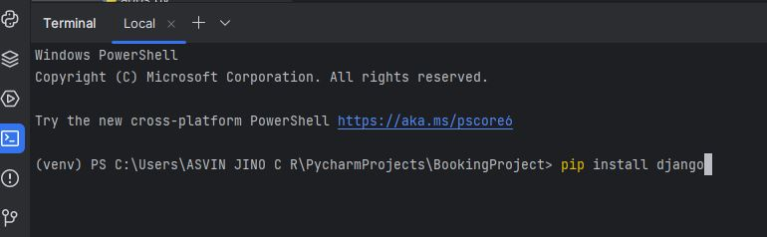

* Create myproject and myapp

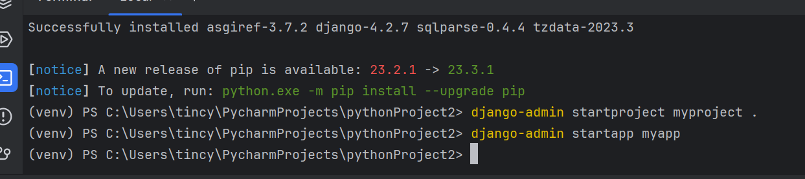

* Create templates and static files
* Create project
* Makemigrations and migrate
* Createsuperuser
* Run server

**PROGRAM FILES**

**Settings.py**

In Django, the settings.py file is a crucial part of this project configuration. It contains various settings that control how Django project behaves.

1. Installed Apps:

INSTALLED_APPS = [  
 'django.contrib.admin',  
 'django.contrib.auth',  
 'django.contrib.contenttypes',  
 'django.contrib.sessions',  
 'django.contrib.messages',  
 'django.contrib.staticfiles',  
 'myapp'  
]

1. Database settings:

DATABASES = {  
 'default': {  
 'ENGINE': 'django.db.backends.sqlite3',  
 'NAME': BASE_DIR / 'db.sqlite3',  
 }  
}

1. Templates:

TEMPLATES = [  
 {  
 'BACKEND': 'django.template.backends.django.DjangoTemplates',  
 'DIRS': [os.path.join(BASE_DIR, 'templates')],  
 'APP_DIRS': True,  
 'OPTIONS': {  
 'context_processors': [  
 'django.template.context_processors.debug',  
 'django.template.context_processors.request',  
 'django.contrib.auth.context_processors.auth',  
 'django.contrib.messages.context_processors.messages',  
 ],  
 },  
 },  
]

4.Email:

STATIC_URL = 'static/'  
EMAIL_BACKEND = 'django.core.mail.backends.smtp.EmailBackend'  
EMAIL_USE_TLS = True  
EMAIL_HOST = 'smtp.gmail.com'  
EMAIL_PORT = 587  
EMAIL_HOST_USER = 'tincycr28@gmail.com'  
DEFAULT_FROM_EMAIL = 'tincycr28@gmail.com'  
SERVER_EMAIL = 'tincycr28@gmail.com'  
EMAIL_HOST_PASSWORD = 'uxfk uqfh nxew uxnc'

**Myproject/urls.py**

It is used to define the URL patterns and routes for this application. It plays a crucial role in directing incoming HTTP requests to the appropriate view functions.

from django.contrib import admin  
from django.urls import path, include  
  
urlpatterns = [  
 path('admin/', admin.site.urls),  
 path('', include('myapp.urls'))  
]

**myapp/urls.py**

In Django each app has its own urls.py file to define URL patterns specific to that app. This allows to organize and encapsulate the URL routing for different parts of application.

from django.urls import path  
from . import views  
  
urlpatterns = [  
 path('', views.home, name='home'),  
 path('register/', views.register, name='register'),  
 path('booking/', views.booking_submit, name='booking'),  
 path('success/', views.success_page, name='success'),

path('contactus/', views.contactus, name='contactus')

]

**Views.py**

View functions that handle incoming HTTP requests and return HTTP responses. It is responsible for processing data, interacting with models, and rendering templates to generate the final response that is sent back to the client.

from django.http import HttpResponse

from django.shortcuts import render, redirect  
from django.contrib.auth.models import User  
from .models import BookingModel  
from datetime import datetime

from django.core.mail import send_mail

def home(request):  
 return render(request, 'home.html')  
  
  
def register(request):  
 if request.method == 'POST':  
 name = request.POST['name']  
 email = request.POST['email']  
 password = request.POST['password']  
  
 # Create a new user  
 user = User.objects.create_user(username=email, email=email, password=password)  
 user.first_name = name  
 user.save()  
  
 # Redirect to the booking page after successful registration  
 return redirect('booking')  
  
 return render(request, 'register.html')  
  
  
def booking_submit(request):  
 if request.method == 'POST':  
 name = request.POST['name']  
 address = request.POST['address']  
 email = request.POST['email']  
 date = request.POST['date']  
 fullday = request.POST.get('fullday', False)  
 firsthalf = request.POST.get('firsthalf', False)  
 secondhalf = request.POST.get('secondhalf', False)  
  
 # Create a new booking record and save it to the database  
 booking = BookingModel(name=name, address=address, email=email, date=date,  
 fullday=fullday, firsthalf=firsthalf, secondhalf=secondhalf)  
 booking.save()  
  
 # Redirect to a success page  
 return redirect('success_page')  
  
 return render(request, 'booking.html')  
  
  
def success_page(request):  
 return render(request, 'success.html')

def contactus(request):  
 if request.method == 'POST':  
 Name = request.POST.get('Name')  
 Email = request.POST.get('Email')  
 Message = request.POST.get('Message')  
 print(Name, Email, Message)  
 send_mail(Name, Message, 'tincycr28@gmail.com', [Email])  
 return HttpResponse('Email send')  
 return render(request, 'contactus.html')

# Create your views here.

**models.py**

Django web applications access and manage data through Python objects referred to as models. Models define the structure of stored data, including the field types and possibly also their maximum size, default values, selection list options, help text for documentation, label text for forms, etc.

from django.contrib.auth.models import User  
from django.db import models  
  
  
class BookingModel(models.Model):  
 name = models.CharField(max_length=100)  
 address = models.CharField(max_length=200)  
 email = models.EmailField()  
 date = models.DateField()  
 fullday = models.BooleanField()  
 firsthalf = models.BooleanField()  
 secondhalf = models.BooleanField()  
  
 def __str__(self):  
 return self.name  
  
  
class contactus(models.Model):  
 Name = models.CharField(max_length=100)  
 Email = models.EmailField()  
 Message = models.TextField()  
  
 def __str__(self):  
 return self.name  
  
# Create your models here.

**admin.py**

It is used to customize the Django admin interface for your models. This is where we can define how the models are displayed and edited in the admin interface.

from django.contrib import admin  
from .models import BookingModel  
  
  
@admin.register(BookingModel)  
class BookingModelAdmin(admin.ModelAdmin):  
 list_display = ('name', 'address', 'email', 'date', 'fullday', 'firsthalf', 'secondhalf')  
 list_filter = ('date', 'fullday', 'firsthalf', 'secondhalf')  
 search_fields = ('name', 'address', 'email')  
 list_editable = ('date', 'fullday', 'firsthalf', 'secondhalf')  
# Register your models here.

**Create Templates and Static**

* Create Image file, CSS file and JavaScript files in Static file.
* Create Html files in templates.

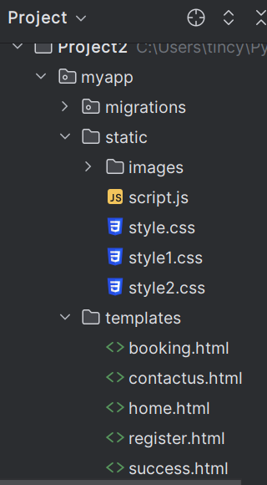

**1.home.html:**

<!DOCTYPE html>  
<html lang="en">  
<head>  
 <meta charset="UTF-8">  
 <meta name="viewport" content="width=device-width, initial-scale=1.0">  
 <title>CR Event Booking</title>  
 {% load static %}  
 <link rel="icon" href="{% static 'images/cricon.png' %}"/>  
<link rel="stylesheet" href="{% static 'style.css' %}">  
 <link rel="stylesheet" href="https://cdn.jsdelivr.net/npm/bootstrap@4.0.0/dist/css/bootstrap.min.css" integrity="sha384-Gn5384xqQ1aoWXA+058RXPxPg6fy4IWvTNh0E263XmFcJlSAwiGgFAW/dAiS6JXm" crossorigin="anonymous">  
 <script src="https://code.jquery.com/jquery-3.2.1.slim.min.js" integrity="sha384-KJ3o2DKtIkvYIK3UENzmM7KCkRr/rE9/Qpg6aAZGJwFDMVNA/GpGFF93hXpG5KkN" crossorigin="anonymous"></script>  
<script src="https://cdn.jsdelivr.net/npm/popper.js@1.12.9/dist/umd/popper.min.js" integrity="sha384-ApNbgh9B+Y1QKtv3Rn7W3mgPxhU9K/ScQsAP7hUibX39j7fakFPskvXusvfa0b4Q" crossorigin="anonymous"></script>  
<script src="https://cdn.jsdelivr.net/npm/bootstrap@4.0.0/dist/js/bootstrap.min.js" integrity="sha384-JZR6Spejh4U02d8jOt6vLEHfe/JQGiRRSQQxSfFWpi1MquVdAyjUar5+76PVCmYl" crossorigin="anonymous"></script>  
<script src="{% static 'script.js' %}"></script>  
</head>  
<body style="background-image:url('{% static 'images/redflower.jpg' %}');background-repeat:no-repeat;background-attachment: fixed;background-size: cover;">  
  
 <nav>  
 <div class="nav-content">  
 <div>  
 <a class="logo" href="#"><img src="static/images/logo2.png" alt="logo" width="70px" height="70px"/></a>  
 </div>  
 <ul class="nav-links">  
 <li><a href="#">Home</a></li>  
 <li><a href="#Gallery">Gallery</a></li>  
 <li><a href="#Services">Services</a></li>  
 <li><a href="{% url 'register' %}">Register</a></li>  
 <li><a href="{% url 'contactus' %}">Contact</a></li>  
 </ul>  
  
 </nav>  
 </div>  
 <div class="content">  
 <h2>Event Planner</h2>  
 <p>CR Mahal is a perfect place in Kanniyakumari  
 <br> for Wedding,Engagement,Birthday,Prayer & Corporate parties etc..</p>  
 <p><a href="register.html" class="btn">Book Now</a></p>  
</div>  
<br>  
<div class="team">  
 <h2>Our Team</h2>  
 </div>  
 <br>  
<div class="row">  
 <div class="column">  
 <div class="card">  
  
 <div class="container">  
 <img src="{% static 'images/girl.png' %}" alt="Tincy" style="width:100px">  
 <h3>Tincy</h3>  
 <p class="title">Managing Director</p>  
 <p>Some text that describes me lorem ipsum ipsum lorem.</p>  
 <p>tincy@gmail.com</p>  
 <p><button class="button">Contact</button></p>  
 </div>  
 </div>  
 </div>  
  
 <div class="column">  
 <div class="card">  
 <div class="container">  
 <img src="{% static 'images/man (1).png' %}" alt="Lijo" style="width:100px">  
 <h2>Lijo</h2>  
 <p class="title">Manager</p>  
 <p>Some text that describes me lorem ipsum ipsum lorem.</p>  
 <p>lijo@gmail.com</p>  
 <p><button class="button">Contact</button></p>  
  
  
 </div>  
 </div>  
 </div>  
<div class="column">  
 <div class="card">  
  
 <div class="container">  
 <img src="{% static 'images/girl.png' %}" alt="Liya" style="width:100px">  
 <h2>Liya</h2>  
 <p class="title">Assistant</p>  
 <p>Some text that describes me lorem ipsum ipsum lorem.</p>  
 <p>liya@gmail.com</p>  
 <p><button class="button">Contact</button></p>  
  
 </div>  
 </div>  
 </div>  
  
 </div>  
</div>  
<br>  
<div id="about-section">  
 <h1>About Us Page</h1>  
 <p>Some text about who we are and what we do.  
 <br>Resize the browser window to see that this page is responsive by the way.</p>  
</div>  
  
<br>  
 <br>  
<div id="Gallery">  
 <h1>Gallery</h1>  
 <p>Some text about who we are and what we do.</p>  
 <p>Resize the browser window to see that this page is responsive by the way.</p>  
</div>  
<br>  
<div class="container1">  
  
 <div class="mySlides">  
 <div class="numbertext">1 / 4</div>  
 <img src="{% static 'images/birthday.jpg' %}" style="width:100%">  
 </div>  
  
 <div class="mySlides">  
 <div class="numbertext">2 / 4</div>  
 <img src="{% static 'images/couplering.jpg' %}" style="width:100%">  
 </div>  
  
 <div class="mySlides">  
 <div class="numbertext">3 / 4</div>  
 <img src="{% static 'images/flowerdecor.jpg'%}" style="width:100%">  
 </div>  
  
 <div class="mySlides">  
 <div class="numbertext">4 / 4</div>  
 <img src="{% static 'images/mehandi hand.jpg' %}" style="width:100%">  
 </div>  
  
 <a class="prev" onclick="plusSlides(-1)">&#10094;</a>  
 <a class="next" onclick="plusSlides(1)">&#10095;</a>  
  
  
 <div class="caption-container1">  
 <p id="caption"></p>  
 </div>  
  
 <div class="row5">  
 <div class="column1">  
 <img class="demo cursor" src="{% static 'images/birthday.jpg' %}" style="width:100%" onclick="currentSlide(1)" alt="Birthday">  
 </div>  
 <div class="column1">  
 <img class="demo cursor" src="{% static 'images/couplering.jpg' %}" style="width:100%" onclick="currentSlide(2)" alt="Engagement">  
 </div>  
 <div class="column1">  
 <img class="demo cursor" src="{% static 'images/flowerdecor.jpg' %}" style="width:100%" onclick="currentSlide(3)" alt="Flower decoration">  
 </div>  
  
 <div class="column1">  
 <img class="demo cursor" src="{% static 'images/mehandi hand.jpg' %}" style="width:100%" onclick="currentSlide(4)" alt="mehandi">  
 </div>  
  
 </div>  
</div>  
<div id="Services">  
 <h1>Services</h1>  
 <p>Some text about who we are and what we do.</p>  
 <p>Resize the browser window to see that this page is responsive by the way.</p>  
</div>  
 <br>  
 <div class="rows">  
 <div class="columns">  
 <div class="cards">  
  
 <div class="containers">  
 <h2 class="title1"><a href="#">ONLINE PAYMENT</a></h2>  
 <p>CR Mahal.com provides a flexibility of various on-line payments of master cards, visa cards,Credit Cards, Net-banking and Paytm wallets.</p>  
 </div>  
 </div>  
 </div>  
  
 <div class="columns">  
 <div class="cards">  
  
 <div class="containers">  
 <h2 class="title1"><a href="#">LIVE BOOKING</a></h2>  
 <p>CR Mahal.com only provides mahal details like phone number, address and landmark, We are provided availability of mahal details also.</p>  
  
 </div>  
 </div>  
 </div>  
 <div class="columns">  
 <div class="cards">  
  
 <div class="containers">  
 <h2 class="title1"><a href="#">Guest Rooms</a></h2>  
 <p>CR Mahal.com only provides availability of guest rooms details also.</p>  
  
 </div>  
 </div>  
 </div>  
  
 </div>  
 </div>  
 <br>  
  
 <div class="footer">  
  
 <div class="content1">  
 <div class="heading">  
 <img src="{% static 'images/logo2.png' %}" alt="logo" width="70px" height="70px"/>  
 </div>  
  
 <div class="social-media">  
 <h4>Social</h4>  
 <div class="social">  
 <p>  
 <a href="#"  
 >Twitter</a  
 >  
 </p>  
  
 <p>  
 <a href=""  
 >Facebook</a  
 >  
 </p>  
 <p>  
 <a href=""  
 >Instagram</a  
 >  
 </p>  
 </div>  
 </div>  
 <div id="openhours">  
 <h4>Open hours</h4>  
 <table class="table" style="border-style: none;">  
 <tr>  
 <td style="border-style: none;">Monday</td>  
 <td style="border-style: none;">9:00am - 5:00pm</td>  
 </tr>  
 <tr>  
 <td style="border-style: none;">Tuesday</td>  
 <td style="border-style: none;">9:00am - 4:00pm</td>  
 </tr>  
 <tr>  
 <td style="border-style: none;">Wednesday</td>  
 <td style="border-style: none;">9:00am - 4:30pm</td>  
 </tr>  
 <tr>  
 <td style="border-style: none;">Thursday</td>  
 <td style="border-style: none;">9:30am - 4:00pm</td>  
 </tr>  
 <tr>  
 <td style="border-style: none;">Friday</td>  
 <td style="border-style: none;">9:30am - 4:00pm</td>  
 </tr>  
 <tr>  
 <td style="border-style: none;">Saturday</td>  
 <td style="border-style: none;">9:30am - 4:00pm</td>  
 </tr>  
 <tr>  
 <td style="border-style: none;">Sunday</td>  
 <td style="border-style: none;">10:30am - 4:00pm</td>  
 </tr>  
  
 </table>  
  
  
 </div>  
 <div id="details">  
 <h4 class="address">Address</h4>  
 <div class="ad">  
 <p>  
 XXXXXXXXX,<br>  
 XXXXXXXXX,<br>  
 Puthukadai(p.o),<br>  
 Kanniyakumari-Dist.  
 </p>  
 <h4 class="mobile">Mobile</h4>  
 <p><a href="#">+91-9999888889</a></p>  
 <h4 class="mail">Email</h4>  
 <p><a href="#">tincy@gmail.com</a></p>  
 </div>  
 </div>  
 </div>  
 <hr />  
 <div class="copy"> © 2023 codewithTincy</div>  
  
 </div>  
  
  
</body>  
</html>

**Style.css:**

*{  
 margin: 0;  
 padding: 0;  
 text-decoration: none;  
 font-family:'Times New Roman', Times, serif;  
}  
body{  
 padding: 10px;  
}  
nav{  
 position: fixed;  
 top: 0;  
 left: 0;  
 width: 100%;  
 padding: 20px;  
 background-color: rgb(238, 209, 209);  
 transition: all 0.4s ease;  
 z-index: 100;  
}  
  
nav .nav-content{  
 height: 100%;  
 max-width: 1200px;  
 margin: auto;  
 display: flex;  
 align-items: center;  
 justify-content: space-between;  
 word-spacing: 50px;  
 margin-right: 100px;  
}  
  
.nav-content .nav-links{  
 display: flex;  
}  
.nav-content .nav-links li{  
 list-style: none;  
 margin: 0 8px;  
}  
 .nav-links li a{  
 text-decoration: none;  
 color: rgb(80, 3, 3);  
 font-size: 20px;  
 font-weight: bold;  
 padding: 10px 4px;  
 transition: all 0.3s ease;  
}  
 .nav-links li a:hover{  
 color: #220a8b;  
 border-bottom: 2px solid cadetblue;  
 }  
  
  
  
.content{  
 text-align: left;  
 justify-content: left;  
 margin-left: 20px;  
 margin-top: 100px;  
 padding-top: 100px;  
}  
.content h2{  
 font-size: 50px;  
 font-weight: 600;  
 color: rgb(25, 8, 87);  
 margin-top: 100px;  
  
}  
.content h2:hover{  
 color: #020e02;  
}  
  
.content p{  
 font-size: 20px;  
 font-weight: 300;  
 color: rgb(25, 8, 87);  
}  
.btn{  
 background-color: #f02b8d;  
 color: white;  
 font-size: 10px;  
 padding: 10px;  
}  
.btn:hover{  
 color: #02151a;  
 background-color: rgb(68, 123, 243);  
 transition: all 0.3s ease;  
 padding: 10px;  
 font-size: 20px;  
}  
.team{  
  
 padding-top: 100px;  
 padding-bottom: 20px;  
 color: rgb(29, 4, 4);  
 font-weight: 600;  
 font-size: 30px;  
 font-family: 'Segoe UI', Tahoma, Geneva, Verdana, sans-serif;  
 align-items: center;  
 text-align: center;  
}  
  
.column {  
 float: left;  
 width: 33.3%;  
 margin-bottom: 16px;  
 padding: 0 8px;  
 z-index:1;  
 overflow-y: auto;  
}  
  
.card {  
 box-shadow: 0 4px 8px 0 rgba(0, 0, 0, 0.2);  
 margin: 8px;  
 z-index:1;  
 overflow-y: auto;  
}  
.container {  
 font-size: 20px;  
 padding: 20px;  
 background-color: #ddc7da;  
 margin-left: 20px;  
 margin-right: 20px;  
 z-index:1;  
 overflow-y: auto;  
}  
  
.container::after, .row::after {  
 content: "";  
 clear: both;  
 display: table;  
}  
  
#about-section {  
 padding: 50px;  
  
 background-color: #c98eabea;  
 color: black;  
 font-size: 20px;  
 margin-top: 100px;  
 margin-left: 20px;  
 margin-right: 20px;  
}  
  
#about-section h1{  
  
 color: rgb(25, 8, 87);  
 font-size: 30px;  
 font-weight: 600;  
}  
#about-section p{  
 padding-top: 20px;  
}  
  
  
  
  
.title {  
 color: rgb(77, 60, 60);  
}  
  
.button {  
 border: none;  
 outline: 0;  
 display: inline-block;  
 padding: 8px;  
 color: white;  
 background-color: #000;  
 text-align: center;  
 cursor: pointer;  
 width: 100%;  
}  
  
.button:hover {  
 background-color: #555;  
}  
  
.navigation .prev {  
 position: absolute;  
 z-index: 10;  
 font-size: 25px;  
 top: 40%;  
 left: 10px;  
 font-weight: 700;  
}  
.navigation .next {  
 right: 10px;  
 position: absolute;  
 font-size: 25px;  
 z-index: 10;  
 top: 40%;  
}  
.navigation .nav-btn {  
 background: rgba(255, 255, 255, 0.55);  
 cursor: pointer;  
 border-radius: 50%;  
 width: 30px;  
 height: 30px;  
 display: flex;  
 justify-content: center;  
 align-items: center;  
 padding: 5px;  
 box-shadow: 2px 2px 10px rgba(0, 0, 0, 0.4);  
}  
.navigation .nav-btn:hover {  
 background: white;  
}  
#Gallery {  
 padding: 50px;  
 text-align: center;  
 background-color: #c98eabea;  
 color: black;  
 font-size: 20px;  
 margin-top: 50px;  
 margin-left: 20px;  
 margin-right: 20px;  
 padding-top: 50px;  
  
}  
  
#Gallery h1{  
 text-decoration: underline;  
 color: rgb(25, 8, 87);  
 font-size: 30px;  
 font-weight: 600;  
}  
.container1 {  
 position: relative;  
 padding-top: 10px;  
 padding-left: 300px;  
 padding-right: 300px;  
}  
.mySlides {  
 display: none;  
}  
  
.cursor {  
 cursor: pointer;  
}  
  
.prev,  
.next {  
 cursor: pointer;  
 position: absolute;  
 top: 40%;  
 width: auto;  
 padding-top: 16px;  
 padding-left: 30px;  
 padding-right: 350px;  
 margin-top: -50px;  
 color: white;  
 font-weight: bold;  
 font-size: 20px;  
 border-radius: 0 3px 3px 0;  
 user-select: none;  
 -webkit-user-select: none;  
}  
.next {  
 right: 0;  
 border-radius: 3px 0 0 3px;  
}  
  
  
  
.numbertext {  
 color: #f2f2f2;  
 font-size: 12px;  
 padding: 8px 12px;  
 position: absolute;  
 top: 0;  
}  
  
.caption-container1 {  
 text-align: center;  
 background-color: #222;  
 padding: 2px 16px;  
 color: white;  
}  
.row5{  
 padding-left: 10px;  
}  
.row5:after {  
 content: "";  
 display: table;  
 clear: both;  
}  
  
.column1 {  
 float: left;  
 width: 16.66%;  
}  
  
.demo {  
 opacity: 0.6;  
}  
  
.active,  
.demo:hover {  
 opacity: 1;  
}  
#Services {  
 padding: 50px;  
 text-align: center;  
 background-color: #c98eabea;  
 color: black;  
 font-size: 20px;  
 margin-top: 20px;  
 margin-left: 20px;  
 margin-right: 20px;  
}  
  
#Services h1{  
 text-decoration: underline;  
 color: rgb(25, 8, 87);  
 font-size: 30px;  
 font-weight: 600;  
}  
.columns {  
 float: left;  
 width: 33.3%;  
 margin-bottom: 16px;  
 padding: 0 8px;  
}  
  
.cards {  
 box-shadow: 0 4px 8px 0 rgba(0, 0, 0, 0.2);  
 margin: 8px;  
}  
.containers {  
 font-size: 20px;  
 padding: 20px;  
 background-color: #ddc7da;  
 margin-left: 20px;  
 margin-right: 20px;  
}  
  
.containers::after, .rows::after {  
 content: "";  
 clear: both;  
 display: table;  
}  
  
.title {  
 color: rgb(77, 60, 60);  
}  
  
  
.footer {  
  
 background-image: linear-gradient(to right,#177762,#095d68,#177762);  
 color: #fefefe;  
 position: fixed;  
 width: 100%;  
 bottom: 0;  
 left: 0;  
}  
  
  
.footer .content1 {  
 display: flex;  
 justify-content: space-evenly;  
  
}  
.footer .content1 .heading{  
 align-items: left;  
 justify-content: left;  
}  
.footer .content1 p {  
 margin-bottom: 1.3rem;  
}  
  
.footer .content1 a {  
 text-decoration: none;  
 color: #fefefe;  
}  
  
.footer .content1 a:hover {  
 border-bottom: 1px solid #971717;  
}  
  
.footer .content1 h4 {  
 margin-bottom: 1.rem;  
 font-size: 19px;  
}  
  
footer {  
 text-align: center;  
 margin-bottom: 2rem;  
}  
  
 hr {  
 margin: 2rem 0;  
 color: #0c0a0c;  
 background-color: #000;  
}  
#openhours{  
 margin-bottom: 20px;  
}  
  
#openhours h4{  
 margin-top: 20px;  
 color: white;  
 font-size: 30px;  
 font-weight: 600;  
 border-bottom: 2px solid rgb(33, 4, 110);  
  
}  
#openhours h4:hover{  
 color: #f3ef19;  
 border-bottom: 2px solid rgb(219, 11, 11);  
}  
  
 .footer {  
 position: unset;  
 }  
.copy{  
 text-align: center;  
 justify-content: center;  
 margin-bottom: 20px;  
 padding-bottom: 10px;  
  
}  
.social-media{  
 margin-bottom: 20px;  
}  
.social-media h4{  
 margin-top: 20px;  
 color: white;  
 font-size: 30px;  
 font-weight: 600;  
 border-bottom: 2px solid rgb(33, 4, 110);  
}  
.social-media h4:hover{  
  
 color: #f3ef19;  
 border-bottom: 2px solid rgb(219, 11, 11);  
}  
.social{  
 margin-top: 30px;  
}  
.table{  
 margin-top: 30px;  
}  
#details{  
 margin-bottom: 20px;  
}  
.address{  
 margin-top: 20px;  
 color: white;  
 font-size: 30px;  
 font-weight: 600;  
 border-bottom: 2px solid rgb(33, 4, 110);  
}  
.address:hover{  
  
 color: #f3ef19;  
 border-bottom: 2px solid rgb(219, 11, 11);  
}  
.ad{  
 margin-top: 30px;  
}

**2.register.html:**

<!DOCTYPE html>  
<html lang="en">  
<head>  
 <meta charset="UTF-8">  
 <meta name="viewport" content="width=device-width, initial-scale=1.0">  
 <title>CR Event Booking</title>  
 {% load static %}  
 <link rel="icon" href="{% static 'images/cricon.png' %}"/>  
<link rel="stylesheet" href="{% static 'style1.css' %}">  
 <link rel="stylesheet" href="https://cdn.jsdelivr.net/npm/bootstrap@4.0.0/dist/css/bootstrap.min.css" integrity="sha384-Gn5384xqQ1aoWXA+058RXPxPg6fy4IWvTNh0E263XmFcJlSAwiGgFAW/dAiS6JXm" crossorigin="anonymous">  
 <script src="https://code.jquery.com/jquery-3.2.1.slim.min.js" integrity="sha384-KJ3o2DKtIkvYIK3UENzmM7KCkRr/rE9/Qpg6aAZGJwFDMVNA/GpGFF93hXpG5KkN" crossorigin="anonymous"></script>  
<script src="https://cdn.jsdelivr.net/npm/popper.js@1.12.9/dist/umd/popper.min.js" integrity="sha384-ApNbgh9B+Y1QKtv3Rn7W3mgPxhU9K/ScQsAP7hUibX39j7fakFPskvXusvfa0b4Q" crossorigin="anonymous"></script>  
<script src="https://cdn.jsdelivr.net/npm/bootstrap@4.0.0/dist/js/bootstrap.min.js" integrity="sha384-JZR6Spejh4U02d8jOt6vLEHfe/JQGiRRSQQxSfFWpi1MquVdAyjUar5+76PVCmYl" crossorigin="anonymous"></script>  
</head>  
<body>  
 <form method="post">  
 <div class="container">  
 <h1 style="color: white; font-size: 40px; font-weight: 600;">Register</h1>  
<label for="name">Name:</label>  
<input type="text" placeholder="Enter your Name" name="name" id="name" required>  
 <br>  
<label for="email"><b>Email:</b></label>  
 <input type="text" placeholder="Enter Email" name="email" id="email" required>  
<br>  
 <label for="psw"><b>Password:</b></label>  
 <input type="password" placeholder="Enter Password" name="psw" id="psw" required>  
<br>  
 <label for="psw-repeat"><b>Repeat Password:</b></label>  
 <input type="password" placeholder="Repeat Password" name="psw-repeat" id="psw-repeat" required>  
 <hr>  
  
 <p>By creating an account you agree to our <a href="#">Terms & Privacy</a>.</p>  
 <div style="align-items: center; justify-content: center;margin-left: 100px;">  
<!-- <button type="submit" style=" outline: none; border: 1px solid red; align-items: center; justify-content: center;"registerbtn">Register</button>-->  
 </div>  
</div>  
</div>  
<br>  
 <div class="container signin">  
 <a href="{% url 'booking' %}">Register</a>  
 </div>  
</form>  
</body>  
</html>

**Style1.css:**

{  
margin: 0;  
padding: 0;  
box-sizing: border-box;  
font-family: 'poppins' , sans-serif;  
cursor: pointer;  
}  
body {  
 height: 100vh;  
 width: 100%;  
 display: flex;  
 justify-content: center;  
 align-items: center;  
 background: linear-gradient(to right,#3f5efb,#fc466b);  
}  
form {  
 width: 25rem;  
 height: 37rem;  
 display: flex;  
 flex-direction: column;  
 background: rgba(56, 19, 14, 0.575);  
 box-shadow: 0 8px 32px 0 , rgba(36, 48, 211, 0.37);  
 border-radius: 30px;  
 border-left: 1px solid rgba(255, 255, 255, 0.3);  
 border-top: 1px solid rgba(255, 255, 255, 0.3);  
}  
#container{  
 margin-left: 10px;  
 font-family: 'Segoe UI', Tahoma, Geneva, Verdana, sans-serif;  
}  
#name{  
 margin-left: 10px;  
 margin-top: 5px;  
 font-family: 'Segoe UI', Tahoma, Geneva, Verdana, sans-serif;  
}  
#psw{  
 margin-left: 10px;  
 margin-top: 5px;  
 font-family: 'Segoe UI', Tahoma, Geneva, Verdana, sans-serif;  
}  
#psw-repeat{  
 margin-left: 10px;  
 margin-top: 5px;  
 font-family: 'Segoe UI', Tahoma, Geneva, Verdana, sans-serif;  
}  
#email{  
 margin-left: 10px;  
 margin-top: 5px;  
 font-family: 'Segoe UI', Tahoma, Geneva, Verdana, sans-serif;  
}  
h1{  
 font-size: 40px;  
 text-align: center;  
 color: white;  
 text-shadow: 2px 2px 4px rgba(0, 0, 0, 0.2);  
 letter-spacing: 3px;  
 margin-bottom: -5%;  
 opacity: 0.7;  
}  
label {  
 font-size: 20px;  
 color: white;  
 margin-left: 10px;  
 opacity: 0.8;  
 text-shadow: 2px 2px 4px rgba(0, 0, 0, 0.2);  
margin-top: 10px;  
}  
input {  
 width: 80%;  
 margin: 5% auto;  
 margin-bottom: 8%;  
 border: none;  
 outline: none;  
 background: rgb(230, 221, 221);  
 color: rgb(14, 2, 2);  
 border-bottom: 1px solid rgba(255, 255, 255, 0.06);  
 opacity: 0.8;  
  
  
}  
  
button {  
 background: linear-gradient(to right,#9da9e2,#7cee99);  
 margin-top:auto;  
 border-radius: 50px;  
 color: rgb(20, 6, 6);  
 font-size: 10px;  
 font-weight: 600;  
 padding: 10px;  
  
 }  
button:hover{  
 color: #02151a;  
 background-color: rgba(68, 123, 243, 0.63);  
 transition: all 0.3s ease;  
 padding: 10px;  
 font-size: 20px;  
 border-radius: 50px;  
}

**3.booking.html:**

<!DOCTYPE html>  
<html lang="en">  
<head>  
 <meta charset="UTF-8">  
 <meta name="viewport" content="width=device-width, initial-scale=1.0">  
 <title>Wedding Hall Booking</title>  
 {% load static %}  
 <link rel="icon" href="{% static 'images/cricon.png' %}"/>  
<link rel="stylesheet" href="{% static 'style2.css' %}">  
 <link rel="stylesheet" href="https://cdn.jsdelivr.net/npm/bootstrap@4.0.0/dist/css/bootstrap.min.css" integrity="sha384-Gn5384xqQ1aoWXA+058RXPxPg6fy4IWvTNh0E263XmFcJlSAwiGgFAW/dAiS6JXm" crossorigin="anonymous">  
 <script src="https://code.jquery.com/jquery-3.2.1.slim.min.js" integrity="sha384-KJ3o2DKtIkvYIK3UENzmM7KCkRr/rE9/Qpg6aAZGJwFDMVNA/GpGFF93hXpG5KkN" crossorigin="anonymous"></script>  
<script src="https://cdn.jsdelivr.net/npm/popper.js@1.12.9/dist/umd/popper.min.js" integrity="sha384-ApNbgh9B+Y1QKtv3Rn7W3mgPxhU9K/ScQsAP7hUibX39j7fakFPskvXusvfa0b4Q" crossorigin="anonymous"></script>  
<script src="https://cdn.jsdelivr.net/npm/bootstrap@4.0.0/dist/js/bootstrap.min.js" integrity="sha384-JZR6Spejh4U02d8jOt6vLEHfe/JQGiRRSQQxSfFWpi1MquVdAyjUar5+76PVCmYl" crossorigin="anonymous"></script>  
</head>  
<body>  
 <form method="POST" id="booking-form">  
 {% csrf_token %}  
  
 <div id="container">  
 <h1>Book Now</h1>  
  
 <label for="name">Name:</label>  
<input type="text" placeholder="Enter your Name" name="name" id="name" required>  
 <br>  
 <label for="address">Address:</label>  
 <input type="text" placeholder="Enter your address" name="address" id="address" required>  
 <br>  
<label for="email"><b>Email:</b></label>  
 <input type="text" placeholder="Enter Email" name="email" id="email" required>  
  
 <br>  
 <label for="date">Date:</label>  
 <input type="date" id="date" required>  
 <br>  
 <div class="checkbox-container">  
 <label for="id_fullday">Fullday</label>  
 <input type="checkbox" name="fullday" id="id_fullday" value="True"><br>  
 <label for="id_firsthalf">First Half</label>  
 <input type="checkbox" name="firsthalf" id="id_firsthalf" value="True"><br>  
  
 <label for="id_secondhalf">Second Half</label>  
 <input type="checkbox" name="secondhalf" id="id_secondhalf" value="True">  
 </div>  
 <br>  
  
 <button type="submit" style="margin-left:100px"><a href="{% url 'success' %}">submit</a></button>  
  
 <div id="legend">  
 <div class="available-dates">  
 Available:  
 </div>  
 <div class="booked-dates">Booked:  
  
 <div class="booked-date">  
  
 </div>  
  
 </div>  
  
 </div>  
 </div>  
 </form>  
</body>  
</html>

**Style2.css**

*{  
margin: 0;  
padding: 0;  
box-sizing: border-box;  
font-family: 'poppins' , sans-serif;  
cursor: pointer;  
}  
body {  
 height: 100vh;  
 width: 100%;  
 display: flex;  
 justify-content: center;  
 align-items: center;  
 background: linear-gradient(to right,#3f5efb,#fc466b);  
}  
  
h1{  
 margin-top: 50px;  
 align-items: center;  
 justify-content: center;  
 text-align: center;  
}  
form {  
 width: 25rem;  
 height: 40rem;  
 display: flex;  
 flex-direction: column;  
 align-items: left;  
 justify-content: left;  
 background: rgba(255, 255, 255, 0.06);  
 box-shadow: 0 8px 32px 0 , rgba(31, 38, 135, 0.37);  
 border-radius: 30px;  
 border-left: 1px solid rgba(255, 255, 255, 0.3);  
 border-top: 1px solid rgba(255, 255, 255, 0.3);  
  
}  
#container{  
margin-left: 10px;  
  
}  
#name{  
margin-left: 10px;  
margin-top: 20px;  
  
}  
#address{  
margin-left: 10px;  
margin-top: 20px;  
  
}  
#date{  
margin-left: 10px;  
margin-top: 20px;  
  
}  
#email{  
margin-left: 10px;  
margin-top: 20px;  
  
}  
.checkbox-container label{  
 display: table;  
 vertical-align: middle;  
 margin: 10px;  
  
 }  
label {  
font-size: 20px;  
color: white;  
margin-left: 10px;  
opacity: 0.8;  
text-shadow: 2px 2px 4px rgba(0, 0, 0, 0.2);  
margin-top: 10px;  
}  
input {  
 width: 50%;  
margin-top: 10px ;  
margin-bottom: 10px;  
border: none;  
outline: none;  
background: rgb(240, 227, 227);  
color: rgb(17, 2, 2);  
border-bottom: 1px solid rgba(255, 255, 255, 0.06);  
opacity: 0.8;  
margin-left: 10px;  
  
}  
  
button {  
 background: white;  
 margin-top:100px;  
 margin-left:300px;  
 border-radius: 50px;  
 color: rgb(20, 6, 6);  
 font-size: 10px;  
 font-weight: 600;  
 padding: 10px;  
  
 }  
button:hover{  
 color: #02151a;  
 transition: all 0.3s ease;  
 padding: 10px;  
 font-size: 20px;  
 border-radius:50px;  
}

**4.success.html:**

<!DOCTYPE html>  
<html>  
<head>  
 <title>Booking Successful</title>  
</head>  
<body>  
 <h1>Booking Successful!</h1>  
 <p>Thank you for your booking.</p>  
  
</body>  
</html>

**5.contactus.html:**

<!DOCTYPE html>  
<html lang="en">  
<head>  
 <meta charset="UTF-8">  
 <meta name="viewport" content="width=device-width, initial-scale=1.0">  
 <title>CR Event Booking</title>  
 {% load static %}  
 <link rel="icon" href="{% static 'images/cricon.png' %}"/>  
 <style>  
 *{  
margin: 0;  
padding: 0;  
box-sizing: border-box;  
font-family: 'poppins' , sans-serif;  
cursor: pointer;  
}  
body {  
 background-image: url('{% static 'images/lilly.jpg' %}');  
 background-repeat:no-repeat;  
 background-attachment: fixed;  
 background-size: cover;  
  
}  
.content{  
max-width: 800px;  
text-align: center;  
}  
.h2{  
align-items: center;  
justify-content: center;  
text-align: center;  
font-size: 30px;  
font-weight: 500;  
color: black;  
margin-top: 10px;  
padding-top:10px;  
}  
.contact{  
position: relative;  
min-height: 100px;  
padding:50px 100px;  
display: flex;  
justify-content: center;  
align-items: center;  
flex-direction: column;  
  
}  
.container{  
width:100%;  
display: flex;  
justify-content: center;  
align-items: center;  
margin-top: 20px;  
}  
.contactInfo{  
width: 50%;  
display: flex;  
flex-direction: column;  
}  
.box{  
position: relative;  
padding: 20px o;  
display: flex;  
}  
.contactForm{  
width: 40%;  
padding: 40px;  
background: pink;  
}  
.inputBox{  
position: relative;  
width: 100%;  
margin-top:10px;  
}  
  
  
 </style>  
</head>  
<body>  
<section class="contact">  
 <div class="content">  
<h2>Contact Us</h2>  
</div>  
<div class="container">  
 <div class="contactInfo">  
 <div class="box">  
 <h3>Phone:</h3>  
 <p>+919999777788</p>  
 </div>  
 <div class="box">  
 <h3>Email:</h3>  
 <p>tincycr28@gmail.com</p>  
 </div>  
 <div class="box">  
 <h3>Address:</h3><br>  
 <p>Marthandam,</p><br>  
 <p>Kanniyakumari,</p><br>  
 <p>TamilNadu,</p><br>  
 <p>Pin:666666</p>  
 </div>  
  
 </div>  
  
<div class="contactForm">  
 <form method="post">  
 {% csrf_token %}  
 <h3>Send Message</h3>  
 <div class="inputBox">  
 <input type="text" name="Name" required>  
 <span>Name</span>  
 </div>  
 <div class="inputBox">  
 <input type="text" name="Email" required>  
 <span>Email</span>  
 </div>  
<div class="inputBox">  
 <input type="text" name="Message" required>  
 <span>Message</span>  
 </div>  
 <div class="inputBox">  
 <input type="submit" name="" value="send" required>  
 </div>  
  
 </form>  
</div>  
 </div>  
 </section>  
</body>  
</html>

**Output**

**View of Event Management System**

**Homepage:**

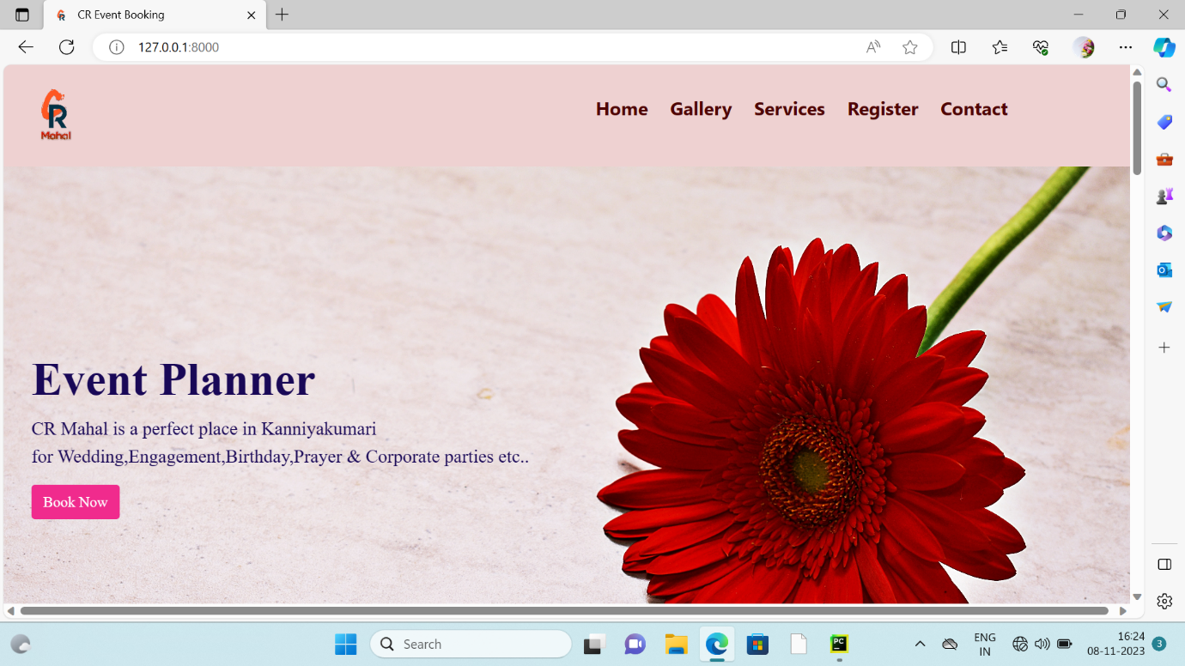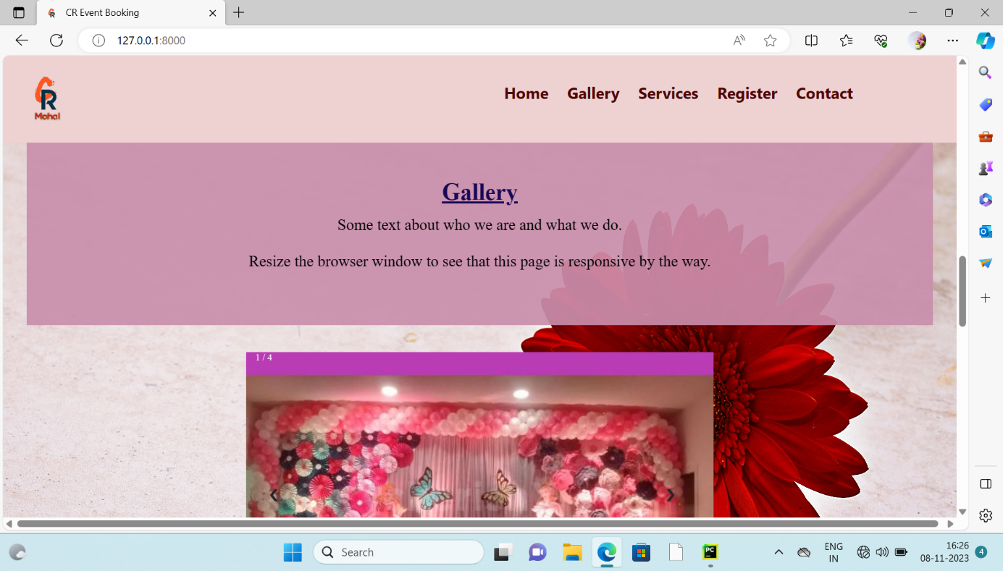

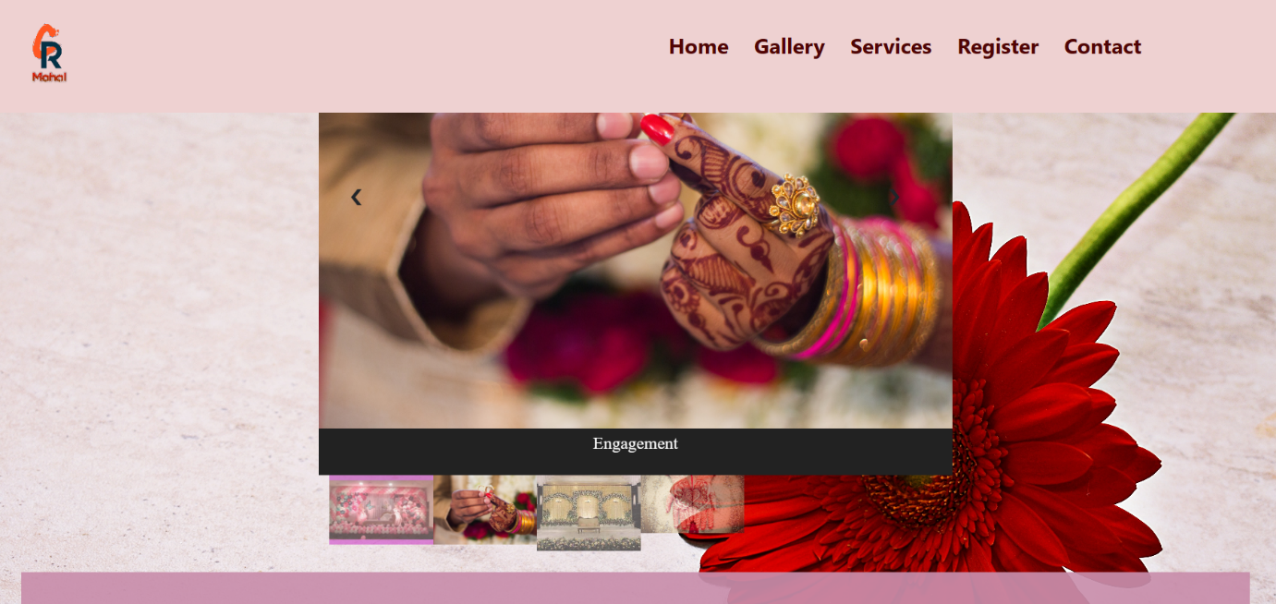

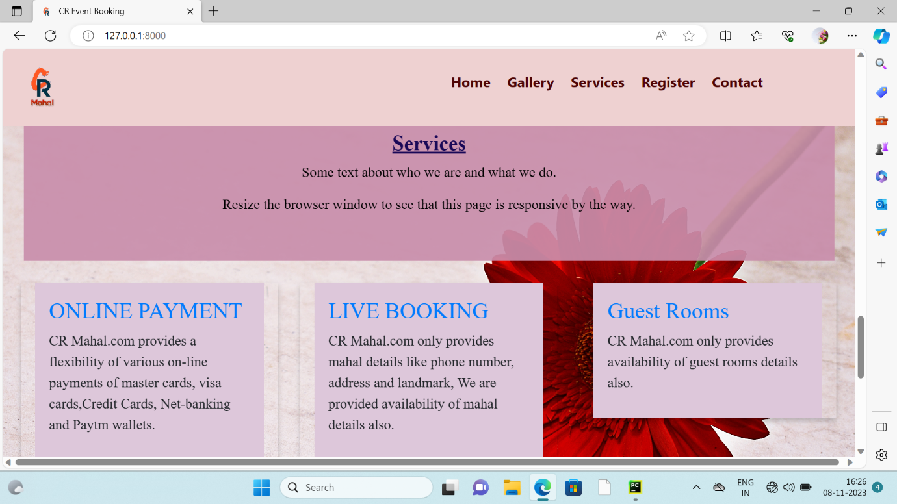

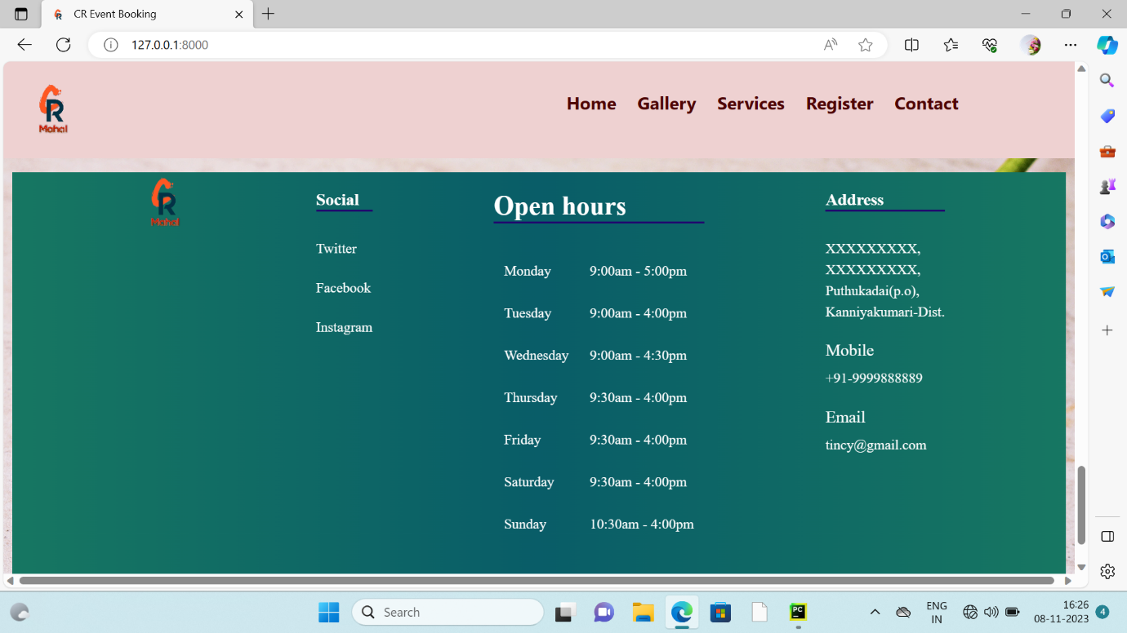

**Register page:**

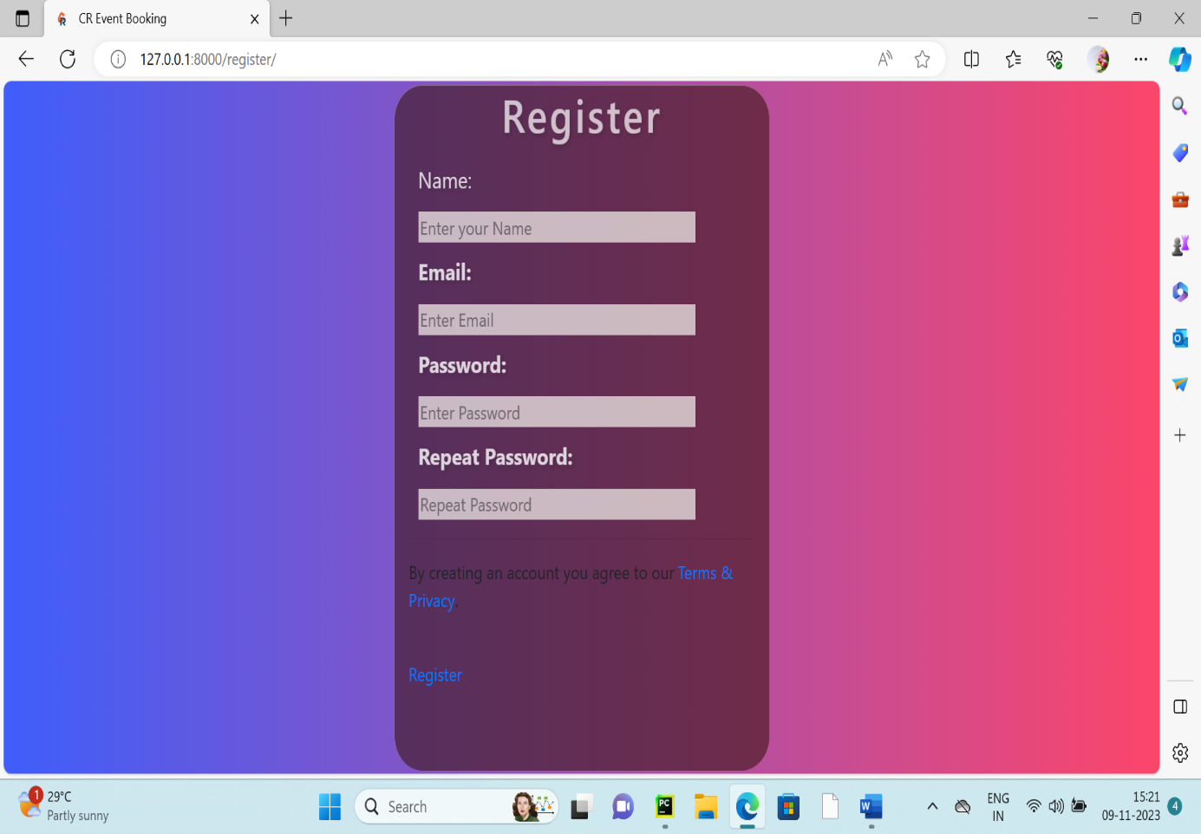

**Booking page:**

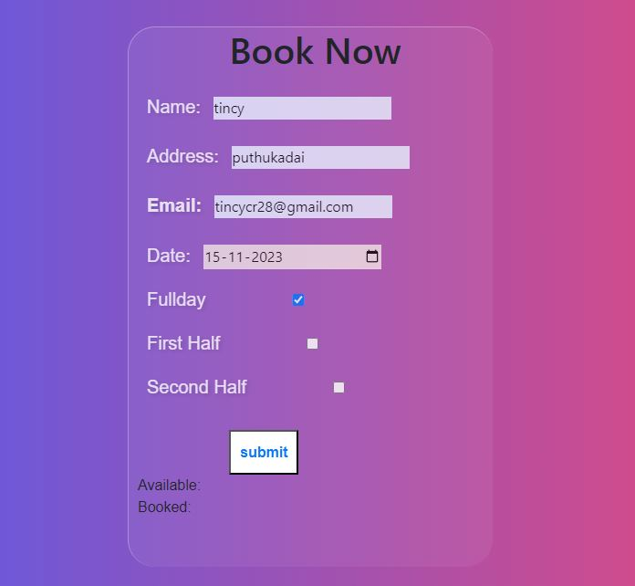

**Success page:**

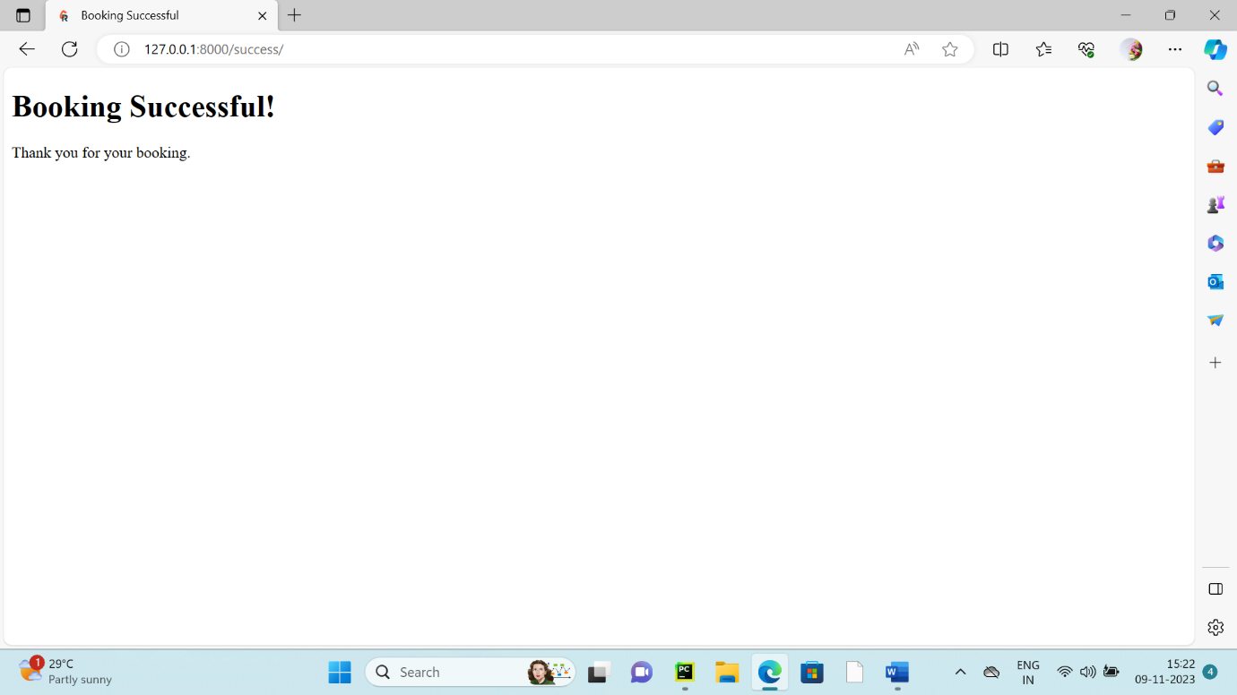

**Contactus page:**

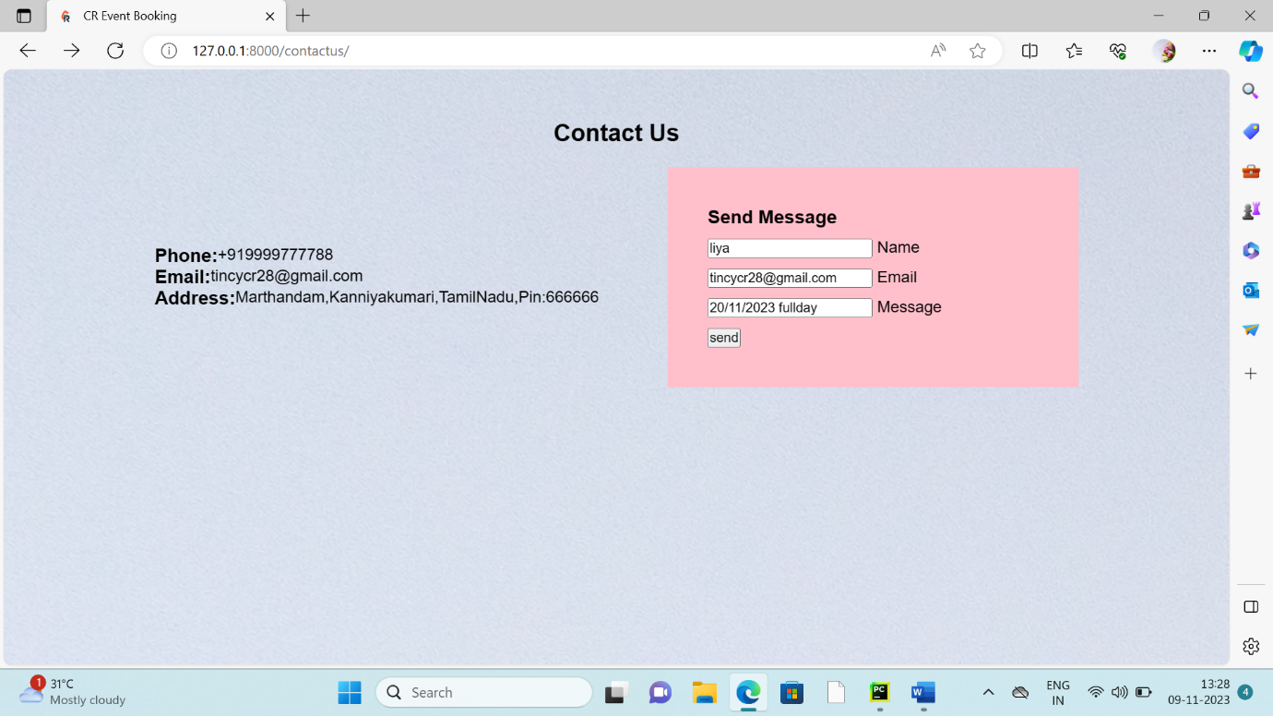

**RESULT (DB-Browser, DjangoAdministration, E-Mail)**

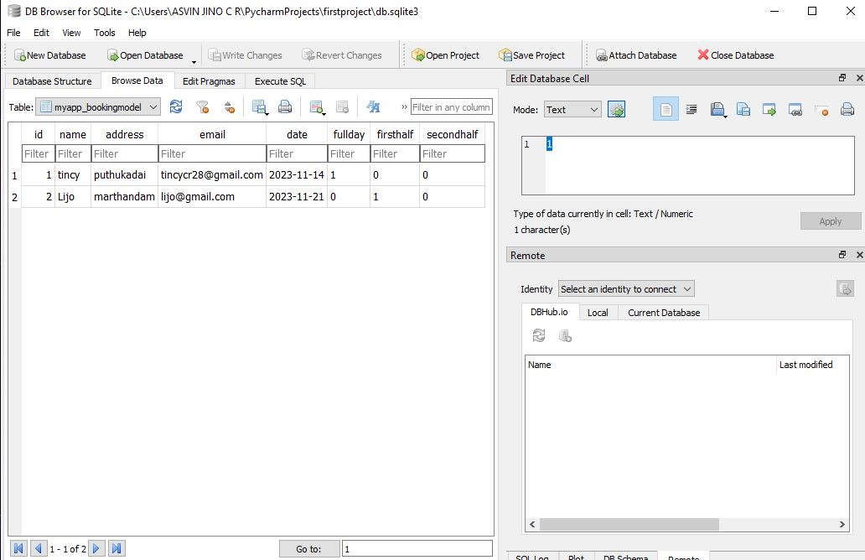

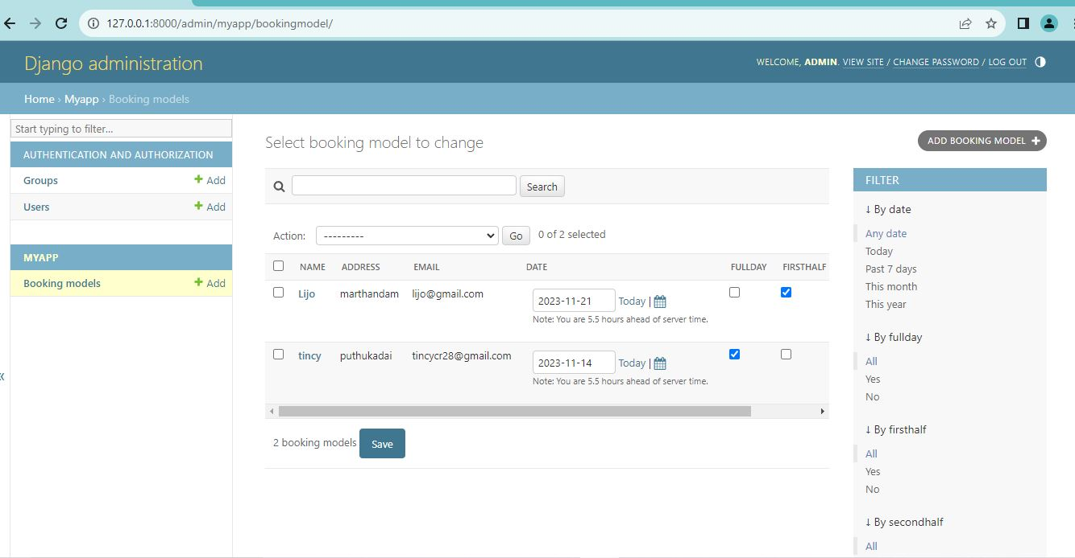

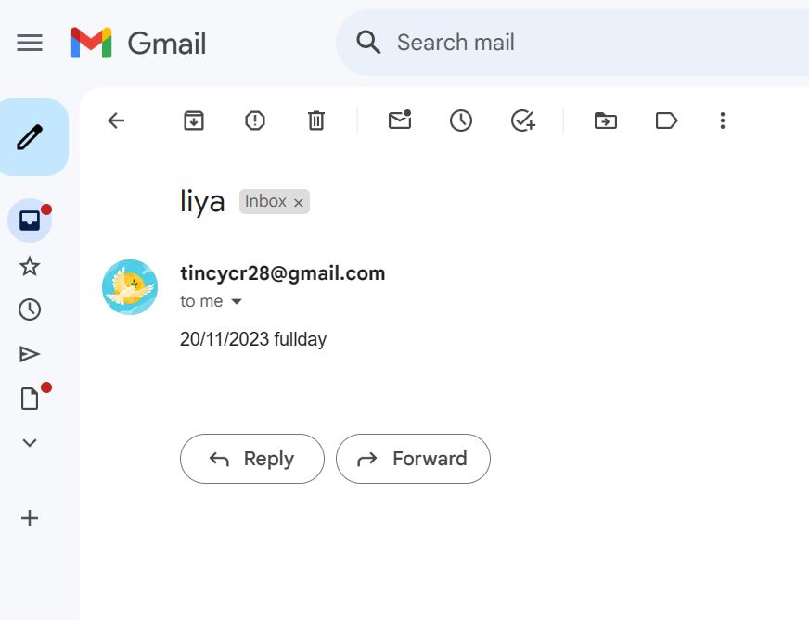

**Conclusion:**

The creation of an event booking website using Django presents an exciting opportunity to develop a robust and user-friendly platform for event organizers and attendees. Leveraging the power of the Django frame work, this project aims to streamline the entire event management and booking process.

The website, built on Django’s foundation, incorporates essential features such as user registration, event booking and also user send messages to management.

As the development progresses, considerations for security, data privacy, and user experience. the Django framework, I have successfully accomplished the requirements of the system. Once this system passes the testing phase, it can be used to serve peoples and instructors. It may still encounter problems during real time use. However, even if that happens, the flexibility of Django would provide a simple way to fix the problem, as well as add new features into the system.